**OBJECT ORIENTED PROGRAMMING LAB**

**Co3 & Co4**

**Jomin K Mathew**

**TKM20MCA2021**

**Roll.no: 20MCA221**

**Program 1**

10/05/2021

**Aim:** Area of different shapes using overloaded functions

**Algorithm:**

Step 1: Start

Step 2: Create a class called areaover.  
Step 3: Create 2 member functions to calculate the area of

rectangle and circle.  
Step 4: Perform the area finding operations inside the

functions.  
Step 5: create object of the class area  
Step 6: call the functions which is created using objects  
Step 7: print the values of area of each shape  
Step 8: Stop

**Source Code:**

package packoops;

import java.util.Scanner;

public class areaover {

public void area(int l,int b) {

System.*out*.println("Area of reactangle is:"+l*b);

}

public void area(float r)

{

System.*out*.println("Area of circle is:"+3.14*r*r);

}

public static void main(String[] args) {

int l,b;

float r;

Scanner obk=new Scanner(System.*in*);

areaover obj=new areaover();

System.*out*.println("Enter the length and breadth of reactangle:");

l=obk.nextInt();

b=obk.nextInt();

System.*out*.println("Enter the radius of the circle:");

r=obk.nextInt();

obj.area(l,b);

obj.area(r);

}

}

**Output:**

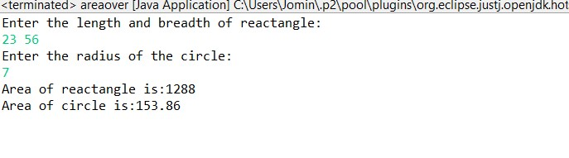

**Program 2**

06/05/2021

**Aim:** Create a class ‘Employee’ with data members Empid,

Name, Salary, Address and constructors to initialize the

data members. Create another class ‘Teacher’ that

inherit the properties of class employee and contain its

own data members department, Subjects taught and

constructors to initialize these data members and also

include display function to display all the data

members. Use array of objects to display details of N

teachers.

**Algorithm:**

Step 1: Start  
Step 2: Create a class employees  
Step 3: Create data members for empid, name salary, address  
Step 4: Create a constructor to initialize these data members  
Step 5: Create another class teacher which is inherited from   
Step 6: Create teacher class’s data members and initialize it with constructor  
Step 7: Create function to display ala datamembers  
Step 8: Create array of objects  
Step 9: call the display function to print all the data members  
Step 10: Stop

**Source Code:**

package Graphics;

import java.util.Scanner;

class employees{

int b;

String c;

String a;

int s;

public employees() {

Scanner obq=new Scanner(System.*in*);

Scanner obq1=new Scanner(System.*in*);Scanner obq2=new Scanner(System.*in*);

System.*out*.println("Enter the employee N.O :");

b=obq.nextInt();

System.*out*.println("Enter the employee Name :");

c=obq1.nextLine();

System.*out*.println("Enter the employee Address :");

a=obq2.nextLine();

System.*out*.println("Enter the employee salary:");

s=obq.nextInt();

}

public void edisplay() {

System.*out*.println("Employee N.O :"+b);

System.*out*.println("Employee Name :"+c);

System.*out*.println("Employee Address :"+a);

System.*out*.println("Employee salary:"+s);

}

}

class teachers extends employees {

String c,a;

public teachers() {

Scanner obq1=new Scanner(System.*in*);

Scanner obq2=new Scanner(System.*in*);

System.*out*.println("Enter the employee deparment :");

c=obq1.nextLine();

System.*out*.println("Enter the employee subject :");

a=obq2.nextLine();

}

void tdisplay() {

System.*out*.println("Employee deparment :"+c);

System.*out*.println("Employee subject :"+a);

}

}

class data extends teachers{

public data() {

}

public void display(int i) {

System.*out*.println("\n"+"----------"+i+"st Employee ---------"+"\n");

tdisplay();

edisplay();

}

}

public class emp{

public static void main(String[] args) {

int a;

Scanner obq=new Scanner(System.*in*);

System.*out*.println("Enter the number of employee :");

a=obq.nextInt();

data[] obj=new data[a];

for(int i=0;i<a;i++)

{

obj[i]=new data();

}

for(int i=0;i<a;i++)

{

obj[i].display(i+1);

}

}

}

**Output:**

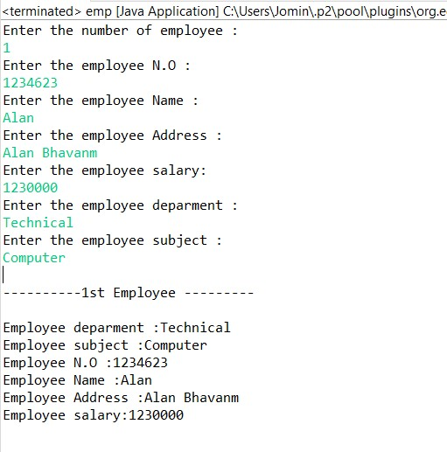

**Program 3**

06/05/2021

**Aim:** Create a class ‘Person’ with data members Name,

Gender, Address, Age and a constructor to initialize

the data members and another class ‘Employee’ that

inherits the properties of class Person and also contains

its own data members like Empid, Company_name,

Qualification, Salary and its own constructor. Create

another class ‘Teacher’ that inherits the properties of

class Employee and contains its own data members like

Subject, Department, Teacherid and also contain

constructors and methods to display the data members.

Use array of objects to display details of N teachers.

**Algorithm:**

Step 1: Start

Step 2: Create a class person with data members for name,

gender, address, age

Step 3: Create constructor to initialize these object

Step 4: Create another class Employee that inherited the

properties of class person and also creates its data

members like empid, companyname , qualification,

salary and its constructor

Step 5: Create another class Teacher that inherits the

properties of class employee and creates its data

members

Step 6: Creates array of object

Step 7: Using these arrays of objects print the values

Step 8: Stop

**Source Code:**

package packoops;

import java.util.Scanner;

class person{

String x,y,z;

int v;

public person() {

Scanner obq=new Scanner(System.*in*);

Scanner obq1=new Scanner(System.*in*);

Scanner obq2=new Scanner(System.*in*);

Scanner obq3=new Scanner(System.*in*);

System.*out*.println("Enter the Name :");

x=obq1.nextLine();

System.*out*.println("Enter the Gender :");

y=obq2.nextLine();

System.*out*.println("Enter the Address :");

z=obq3.nextLine();

System.*out*.println("Enter the employee Age:");

v=obq.nextInt();

}

}

class employees extends person {

int b;

String c;

String a;

int s;

public employees() {

Scanner obq=new Scanner(System.*in*);

Scanner obq1=new Scanner(System.*in*);Scanner obq2=new Scanner(System.*in*);

System.*out*.println("Enter the employee Id :");

b=obq.nextInt();

System.*out*.println("Enter the employee Company Name :");

c=obq1.nextLine();

System.*out*.println("Enter the employee Qualification :");

a=obq2.nextLine();

System.*out*.println("Enter the employee salary:");

s=obq.nextInt();

}

}

class teachers extends employees {

String c,a;

int p;

public teachers() {

Scanner obq1=new Scanner(System.*in*);

Scanner obq2=new Scanner(System.*in*);

Scanner obq3=new Scanner(System.*in*);

System.*out*.println("Enter the Deparment :");

c=obq1.nextLine();

System.*out*.println("Enter the Subject :");

a=obq2.nextLine();

System.*out*.println("Enter the Teacher Id :");

p=obq3.nextInt();

}

public void tdisplay() {

System.*out*.println("Deparment :"+c);

System.*out*.println("Subject :"+a);

System.*out*.println("Teacher Id :"+p);

}

}

class data extends teachers{

public data() {

}

public void display(int i) {

System.*out*.println("\n"+"----------"+i+"st Employee ---------"+"\n");

tdisplay();

}

}

public class corp{

public static void main(String[] args) {

int a;

Scanner obq=new Scanner(System.*in*);

System.*out*.println("Enter the number of Person to be added :");

a=obq.nextInt();

data[] obj=new data[a];

for(int i=0;i<a;i++)

{

obj[i]=new data();

}

for(int j=0;j<a;j++)

{

obj[j].display(j+1);

}

}

}

**Output:**

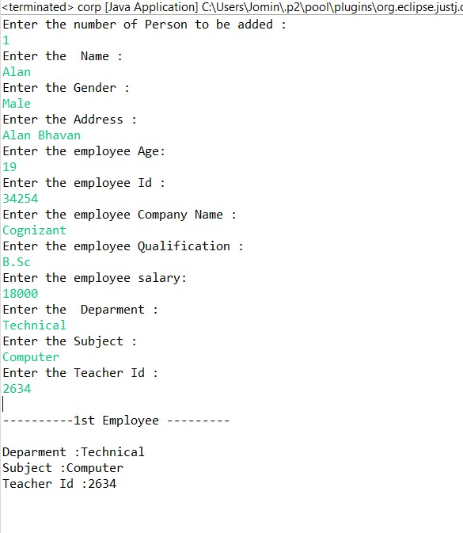

**Program 4**

06/05/2021

**Aim:** Write a program has class Publisher, Book, Literature

and Fiction. Read the information and print the details

of books from either the category, using inheritance.

**Algorithm:**

Step 1: Start

Step 2: Create a class publisher, Book, Literature and Fiction using inheritance  
Step 3: Create each class’s data members and member functions.  
Step 4: Read this information from the user  
Step 5: Print the details of book from the category  
Step 6: Stop.

**Source Code:**

package packoops;

import java.util.Scanner;

class publisher {

String p_name;

int p_year;

Scanner sc=new Scanner(System.*in*);

publisher()

{

System.*out*.println("Enter Publisher name");

p_name=sc.next();

System.*out*.println("Enter the Year of Publication");

p_year=sc.nextInt();

}

}

class book extends publisher {

String b_name,b_author;

int b_price;

Scanner sc=new Scanner(System.*in*);

book() {

System.*out*.println("Enter Book name");

b_name=sc.next();

System.*out*.println("Enter author");

b_author=sc.next();

System.*out*.println("Enter price");

b_price=sc.nextInt();

}

}

class literature extends book {

int page;

Scanner sc=new Scanner(System.*in*);

literature() {

System.*out*.println("Enter number of pages: ");

page=sc.nextInt();

}

void display(int i)

{

System.*out*.println("........"+i+"st LITERATURE ........");

System.*out*.println("Publisher name is "+p_name);

System.*out*.println("Published year is "+p_year);

System.*out*.println("Book name is "+b_name);

System.*out*.println("Autho name is "+b_author);

System.*out*.println("Price is "+b_price);

}

}

class fictions extends book {

int page;

Scanner sc=new Scanner(System.*in*);

fictions() {

System.*out*.println("Enter number of pages");

page=sc.nextInt();

}

void display(int i)

{

System.*out*.println("......... "+i+"st FICTION BOOK .........");

System.*out*.println("Publisher name is "+p_name);

System.*out*.println("Published year is "+p_year);

System.*out*.println("Book name is "+b_name);

System.*out*.println("Autho name is "+b_author);

System.*out*.println("Price is "+b_price);

}

}

public class inheritance {

public static void main(String[] args) {

int n,m,c,choice;

Scanner sc=new Scanner(System.*in*);

System.*out*.println("Choices");

System.*out*.println("1.literature.");

System.*out*.println("2.fiction.");

System.*out*.println("Enter the choice:");

choice=sc.nextInt();

switch(choice)

{

case 1:

System.*out*.println("Enter number of literatures books");

n=sc.nextInt();

literature l[]=new literature[n];

for(int i=0;i<n;i++) {

l[i]=new literature();

}

for(int i=0;i<n;i++) {

l[i].display(i+1);

}

break;

case 2:

System.*out*.println("Enter number of fictions books");

m=sc.nextInt();

fictions f[]=new fictions[m];

for(int i=0;i<m;i++) {

f[i]=new fictions();

}

for(int i=0;i<m;i++) {

f[i].display(i+1);

}

break;

default:

System.*out*.println("invalid choice");

break;

}

}

}

**Output:**

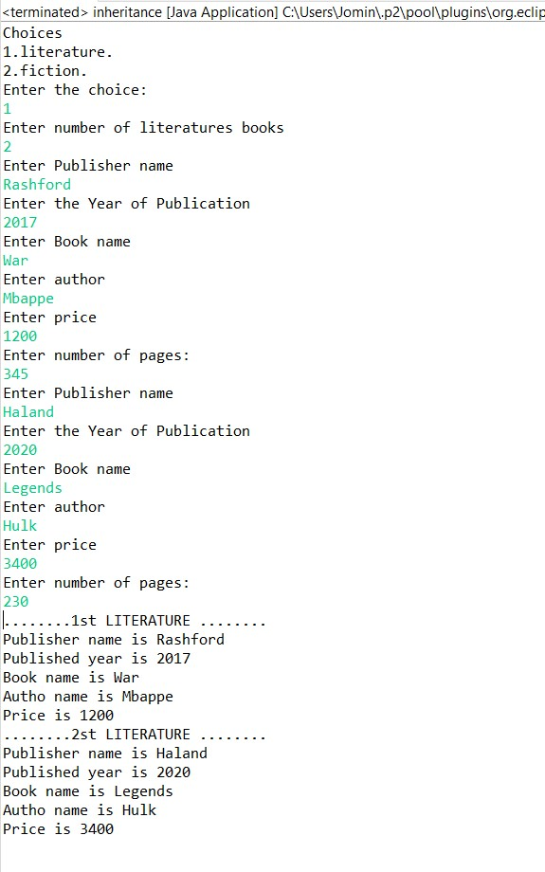

**Program 5**

06/05/2021

**Aim:** Create classes Student and Sports. Create another class

Result inherited from Student and Sports. Display the

academic and sports score of a student.

**Algorithm:**

Step 1: Start

Step 2: Create classes student and sports  
Step 3: Create another class Result inherited from Student and

Sports  
Step 4: Create a function called display to print  
Step 5: Display academic and sports score of student  
Step 6: Stop

**Source Code:**

package packoops;

import java.util.Scanner;

class student {

String name;

int maths,english,science;

Scanner sc=new Scanner(System.*in*);

public student() {

System.*out*.println("Enter the name of the student");

name=sc.next();

System.*out*.println("Enter the mark of Maths");

maths=sc.nextInt();

System.*out*.println("Enter the mark of English");

english=sc.nextInt();

System.*out*.println("Enter the mark of Science");

science=sc.nextInt();

}

}

class sports extends student{

String athletics,football,basketball;

public sports() {

System.*out*.println("Enter the Grade of athletics");

athletics=sc.next();

System.*out*.println("Enter the Grade of football");

football=sc.next();

System.*out*.println("Enter the Grade of basketball");

basketball=sc.next();

}

}

class result extends sports{

public result() {

}

int total=maths+english+science;

void display(){

System.*out*.println("------Marklist of "+name+"------");

System.*out*.println("Subject ");

System.*out*.println("Maths : "+maths);

System.*out*.println("English : "+english);

System.*out*.println("Science : "+science);

System.*out*.println("Total : "+total);

System.*out*.println("--Sports-- ");

System.*out*.println("Athletics : "+athletics);

System.*out*.println("Football : "+football);

System.*out*.println("Basketball : "+basketball);

}

}

public class acadamic {

public static void main(String[] args) {

int b;

Scanner obj1=new Scanner(System.*in*);

System.*out*.println("Enter the number of Person to be added :");

b=obj1.nextInt();

result[] obj=new result[b];

for(int i=0;i<b;i++)

{

obj[i]=new result();

}

for(int j=0;j<b;j++)

{

obj[j].display();

}

}

}

**Output:**

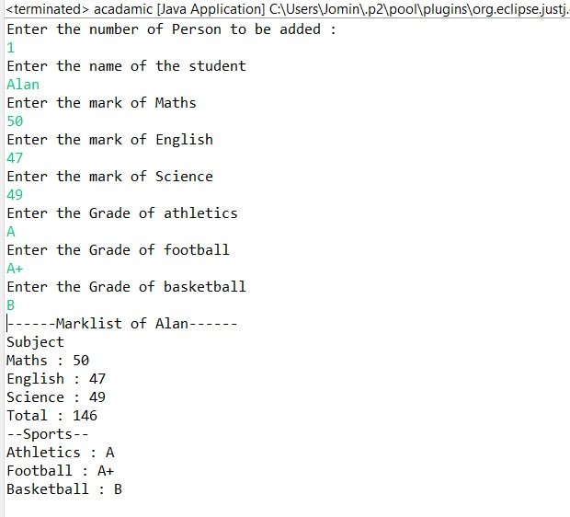

**Program 6**

06/05/2021

**Aim:** Create an interface having prototypes of functions

area() and perimeter(). Create two classes Circle and

Rectangle which implements the above interface.

Create a menu driven program to find area and

perimeter of objects.

**Algorithm:**

Step 1: Start

Step 2: Create an interface having prototypes of function

area() and perimeter()  
Step 3: Create classes that implements the interface  
Step 4: Create two classes circle and rectangle  
Step 5: find the perimeter and area of rectangle and circle  
Step 6: Print the results  
Step 7: Stop

**Source Code:**

package packoops;

import java.util.Scanner;

interface process{

void data();

void area();

void premeter();

}

class Circle implements process{

float r;

double area1,premeter1;

public void data()

{

Scanner obj=new Scanner(System.*in*);

System.*out*.println("Enter The radius Circle");

r=obj.nextInt();

}

public void area() {

area1=3.14*r*r;

System.*out*.println("Area:"+area1);

}

public void premeter() {

premeter1=2*3.14*r;

System.*out*.println("Premeter:"+premeter1);

}

}

class Rectangle implements process{

int l,b,area1,premeter1;

public void data()

{

Scanner obj=new Scanner(System.*in*);

System.*out*.println("Enter The Length of Rectangle");

l=obj.nextInt();

System.*out*.println("Enter The Breadth of Rectangle");

b=obj.nextInt();

//area1=l*b;

//premeter1=2*(l+b);

}

public void area() {

area1=l*b;

System.*out*.println("Area of Rectangle:"+area1);

}

public void premeter() {

premeter1=2*(l+b);

System.*out*.println("Premeter of Rectangle:"+premeter1);

}

}

public class diamension {

public static void main(String[] args) {

Rectangle obj1=new Rectangle();

Circle obj2=new Circle();

int r;

obj2.data();

obj2.area();

obj2.premeter();

obj1.data();

obj1.area();

obj1.premeter();

}

}

**Output:**

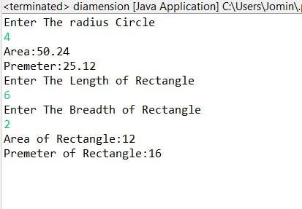

**Program 7**

06/05/2021

**Aim:** Prepare bill with the given format using calculate

method from interface. Order No.

Date :

Product Id Name Quantity unit price Total

101 A 2 25 50

102 B 1 100 100

Net. Amount 150

**Algorithm:**

STEP 1: Create a class Bill  
STEP 2: Create interface billing and create class section implements from billing.  
STEP 3: Create a display function  
STEP 4: Print the values as shown as the question  
STEP 5: Stop

**Source Code:**

package packoops;

import java.util.Scanner;

import java.time.format.DateTimeFormatter;

import java.time.LocalDateTime;

interface billing{

public void product();

public int calculation();

}

class section implements billing{

int prdtid,orderid,quanity,price,total;

String prdtname;

int pprice;

Scanner obj1=new Scanner(System.in);

public void product() {

System.out.println("Enter the Product Id");

prdtid=obj1.nextInt();

System.out.println("Enter the Product Name");

prdtname=obj1.next();

System.out.println("Enter the Quantity");

quanity=obj1.nextInt();

System.out.println("Enter the Price");

price=obj1.nextInt();

}

public int calculation() {

pprice =price*quanity;

return pprice;

}

public void display(int i) {

System.out.println(i+". "+"\t"+prdtid+"\t"+prdtname+"\t\t"+quanity+"\t"+price+" \t"+pprice);

}

}

public class Bill {

public static void main(String[] args) {

int p=0,ch=0,total=0,ttotal=0,count=0;

DateTimeFormatter dtf = DateTimeFormatter.ofPattern("yyyy/MM/dd \n\t\t\t\t\t HH:mm:ss");

LocalDateTime now = LocalDateTime.now();

Scanner obj=new Scanner(System.in);

section[] obj1 = new section[5] ;

System.out.println("Enter the Choice");

while(ch<3) {

System.out.println("1.Add"+"\t"+"2.Print"+"\t"+"3.Exit");

ch=obj.nextInt();

switch(ch) {

case 1:

count=count+1;

obj1[count] = new section();

obj1[count].product();

ttotal=obj1[count].calculation();

total=total+ttotal;

break;

case 2:

System.out.println("\t\t\t\tDate & Time: "+dtf.format(now));

System.out.println("Slno "+" Pdt_Id"+"\t"+"Pdt_Name"+"\t"+"Qty"+"\t"+"Rate" + "\t"+"Amount");

System.out.println("-----------------------------------------------");

for(int i=1;i<count+1;i++) {

obj1[i].display(i);

}

System.out.println("-----------------------------------------------");

System.out.println("\t\t\t\t\t total :"+total+"\n");

break;

default:

System.out.println("");

break;

}

}

}

}

**Output:**

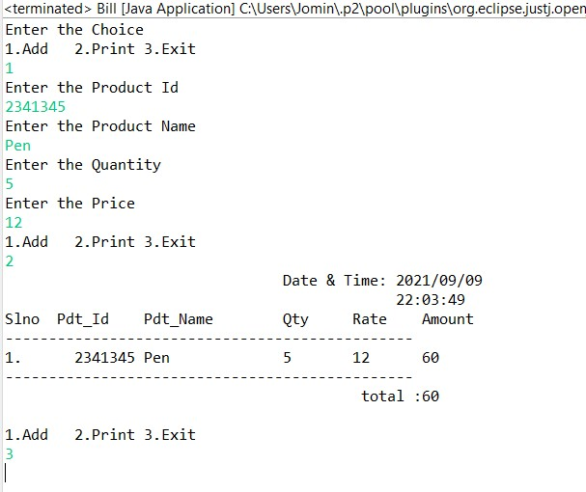

**Program 8**

07/06/2021

**Aim:** Create a Graphics package that has classes and

interfaces for figures Rectangle, Triangle, Square and

Circle. Test the package by finding the area of these

figures.

**Algorithm:**

Step 1: Start

Step 2: Define a package contain functions to assign calculate and display.

Step 3: Read inputs from user and assign values to objects.

Step 4: Perform desired operations.

Step 5: Print the Outputs.

Step 6: Stop

**Source Code:**

***test.java***

package Main;

import java.util.Scanner;

import packoops.Dimension;

public class test {

public static void main(String[] args) {

Scanner obk=new Scanner(System.in);

Dimension obj=new Dimension();

int ch=0;

while(ch<5) {

System.out.println("Choose the Shape to find the area:"+"\n 1.Rectangle \t 2.Triangle \n 3.Circle \t 4.Sqaure \t 5.Exit");

ch=obk.nextInt();

switch(ch) {

case 1:

obj.rectangle();

break;

case 2:

obj.triangle();

break;

case 3:

obj.circle();

break;

case 4:

obj.square();

break;

case 5: break;

default:

System.out.println("invalid choice");

break;

}

}

}

}

***Dimension.java***

package packoops;

import java.util.Scanner;

interface calculation{

public void rectangle();

public void triangle();

public void circle();

public void square();

}

public class Dimension implements calculation {

double area;

Scanner obj1=new Scanner(System.*in*);

public void rectangle() {

int l,b;

System.*out*.println("Enter the length of the rectangle:");

l=obj1.nextInt();

System.*out*.println("Enter the Breath of the rectangle:");

b=obj1.nextInt();

area=l*b;

System.*out*.println("Area:"+area+"\n");

}

public void triangle() {

int h,b;

System.*out*.println("Enter the base of the Triangle:");

b=obj1.nextInt();

System.*out*.println("Enter the height of the Triangle:");

h=obj1.nextInt();

area=(h*b)/2;

System.*out*.println("Area:"+area+"\n");

}

public void circle() {

float r;

System.*out*.println("Enter the Radius of the Circle:");

r=obj1.nextInt();

area=3.14*r*r;

System.*out*.println("Area:"+area+"\n");

}

public void square() {

int s;

System.*out*.println("Enter the Side of the Square:");

s=obj1.nextInt();

area=s*s;

System.*out*.println("Area:"+area+"\n");

}

}

# Output :

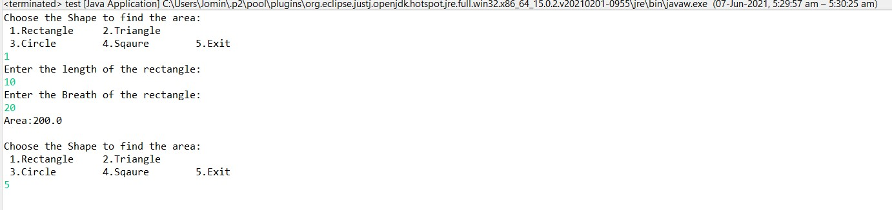

**Program 9**

10/06/2021

**Aim:** Create an Arithmetic package that has classes and

interfaces for the 4 basic arithmetic operations. Test the

package by implementing all operations on two given

numbers.

**Algorithm:**

Step 1: Start

Step 2: Define a package contain functions to assign calculate and display.

Step 3: Read inputs from user and assign values to objects.

Step 4: Perform desired operations.

Step 5: Print the Outputs.

Step 6: Stop

**Source Code:**

***oper.java***

package Main;

import packoops.Operation;

import Graphics.Dimension;

import java.util.Scanner;

public class oper {

public static void main(String[] args) {

Operation obj=new Operation();

Scanner obk=new Scanner(System.in);

System.out.println("Enter the 1st number");

int a=obk.nextInt();

System.out.println("Enter the 2st number");

int b=obk.nextInt();

int ch=0;

obj.data(a, b);

while(ch<5) {

System.out.println("Choose the Operation :"+"\n 1.Addition \t 2.Subtration \n 3.Multiplication \t 4.Division \t 5.Exit");

ch=obk.nextInt();

switch(ch) {

case 1:

obj.add();

break;

case 2:

obj.sub();

break;

case 3:

obj.mult();

break;

case 4:

obj.div();

break;

case 5: break;

default:

System.out.println("invalid choice");

break;

}

}

}

}

***Operation.java***

package packoops;

interface arith {

public void add();

public void sub();

public void mult();

public void div();

}

public class Operation implements arith{

int x,y;

public void data(int a,int b) {

x=a;

y=b;

}

public void add() {

int s;

s=x+y;

System.*out*.println("Addition :"+s);

}

public void sub() {

int m;

m=x-y;

System.*out*.println("Subtration :"+m);

}

public void mult() {

int p;

p=x*y;

System.*out*.println("Multiplication :"+p);

}

public void div() {

float d;

d=x/y;

System.*out*.println("Division :"+d);

}

}

**Output:**

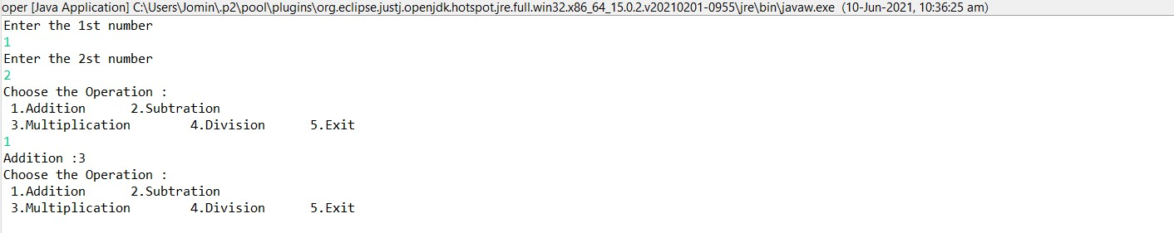

**Program 10**

10/06/2021

**Aim:** Write a user defined exception class to authenticate the

user name and password.

**Algorithm:**

Step 1: Start

Step 2: Read inputs as username and password.

Step 3: Verify the username and password.

Step 4: If its true; Print Authentication successful.

Step 5: Else print invalid.

Step 6: Stop

**Source Code:**

package packoops;

import java.util.Scanner;

class authException extends Exception

{

public authException(String s) {

super(s);

}

}

public class login

{

public static void main(String[] args) {

String username = "jomin";

String passcode = "123";

String user_name,password;

Scanner sc = new Scanner(System.*in*);

try

{

System.*out*.println("Username:");

user_name = sc.nextLine();

System.*out*.println("Password:");

password = sc.nextLine();

if(username.equals(user_name) && passcode.equals(password))

{

System.*out*.println("Authentication successful...");

}

else

throw new authException("Invalid user credentials");

}

catch(authException e)

{

System.*out*.println("Exception caught "+e);

}

}

}

**Output:**

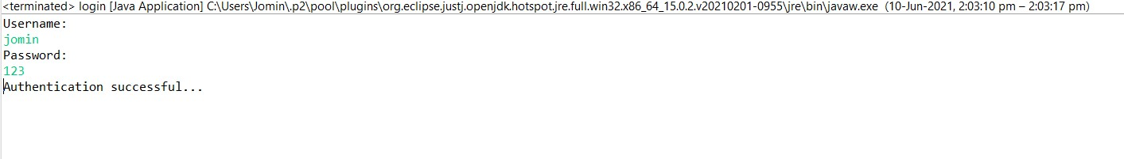

**Program 11**

10/06/2021

**Aim:** Find the average of N positive integers, raising a user

defined exception for each negative input.

**Algorithm:**

Step 1: Start

Step 2: Enter a limit n.

Step 3: Read n elements.

Step 4: Iterate the loop .

Step 5: if(num[i]>0) then

Step 6: total += num[i] ,count++;

Step 7: Else Print error message

Step 8: Average=total/count

Step 9: Print Average

Step 10: Stop

**Source Code:**

package packoops;

import java.util.Scanner;

class NegativeIntegerException extends Exception

{

public NegativeIntegerException(String s)

{

super(s);

}

}

public class average {

public static void sample()

{

try {

int n,count=0;

float num[];

float total=0;

Scanner sc = new Scanner(System.*in*);

System.*out*.print("Enter the number of values =>");

n = sc.nextInt();

num = new float[n];

System.*out*.println("Enter the numbers =>");

for(int i=0;i<n;i++)

{

num[i] = sc.nextInt();

try{

if(num[i]<0)

{

throw new NegativeIntegerException("Negative integer");

}

else

{

total += num[i];

count++;

}

}catch(NegativeIntegerException e)

{

System.*out*.println("Exception caught "+e);

}

}

System.*out*.println("Average = "+(total/count));

} catch (Exception e) {

System.*out*.println("Exception caught "+e);

}

}

public static void main(String[] args) {

try {

*sample*();

} catch (Exception e) {

}

}

}

**Output:**

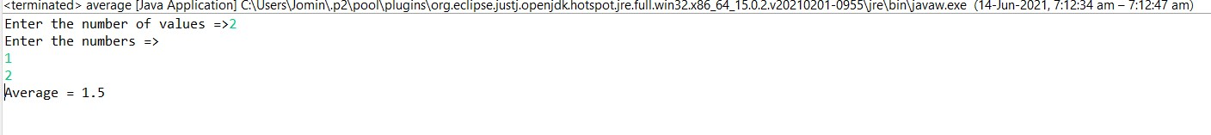

**Program 12**

01/09/2021

**Aim:** Define 2 classes; one for generating multiplication table

of 5 and other for displaying first N prime numbers.

Implement using threads. (Thread class).

**Algorithm:**

Step 1: Start

Step 2: Define a class for multiplication and another for prime numbers.

Step 3: Print the multiplication table of 5.

Step 4: Input the limit for prime numbers.

Step 5: Print prime numbers.

Step 6: Stop

**Source Code:**

package packoops;

import java.util.Scanner;

public class mult {

public static void main(String[] args) throws InterruptedException {

multiplication_tbl a = new multiplication_tbl();

prime_num b = new prime_num();

a.start();

a.*sleep*(200);

b.start();

b.*sleep*(200);

}

}

class multiplication_tbl extends Thread{

public void run(){

int n=10;

Scanner sc= new Scanner(System.*in*);

System.*out*.println("Multiplication of Five");

for(int i=1;i<=10;i++)

{

System.*out*.println(+i+"x 5 =>"+(i*5));

}

}

}

class prime_num extends Thread{

public void run() {

int n,i=3,count,m;

Scanner sc= new Scanner(System.*in*);

System.*out*.println("Enter limit for prime numbers:");

n=sc.nextInt();

if(n >=1)

{

System.*out*.println("First prime" +n+ "numbers are:");

System.*out*.println("2");

for(count = 2; count <= n; i++)

{

for(m= 2; m < i;m++)

{

if(i%m == 0)

break;

}

if(m== i)

{

System.*out*.println(i);

count++;

}

}

}

}}

**Output:**

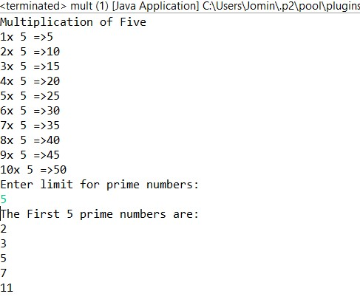

**Program 13**

17/06/2021

**Aim:** Define 2 classes; one for generating Fibonacci numbers

and other for displaying even numbers in a given range.

Implement using threads. (Runnable Interface).

**Algorithm:**

Step 1: Start

Step 2: Define a class for Fibonacci and another for even numbers.

Step 3: Print the Fibonnaci series of 20 number.

Step 4: Input the limit for even numbers.

Step 5: Print n even numbers.

Step 6: Stop

**Source Code:**

package packoops;

import java.util.Scanner;

class Fibonacci implements Runnable{

public void run(){

int a=0,b=1,c=0,l=20;

System.*out*.println("FIBONACCI SERIES UPTO "+l+": \n");

while (l>0)

{

System.*out*.print(c+" ");

a=b;

b=c;

c=a+b;

l=l-1;

if(l%10==0)

{

System.*out*.println("\n");

}

}

}

}

class EvenNumber implements Runnable{

public void run(){

int n;

Scanner sc=new Scanner(System.*in*);

System.*out*.println("Enter the limit : ");

n=sc.nextInt();

System.*out*.println("Even Numbers from 1 to "+n+"\n");

for(int i=1;i<=n;i++) {

if(i%2==0) {

System.*out*.println(i);

}

}

}

}

public class fib {

public static void main(String[] args) {

Fibonacci obj1=new Fibonacci();

Thread t1=new Thread(obj1);

t1.start();

EvenNumber obj2=new EvenNumber();

Thread t2=new Thread(obj2);

t2.start();

}

}

**Output:**

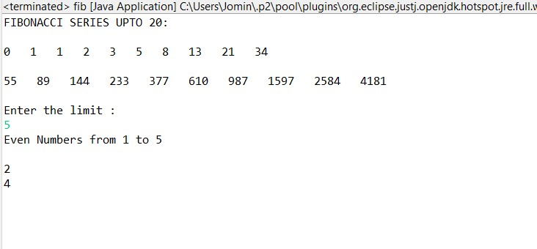

**Program 14**

21/06/2021

**Aim:** Producer/Consumer using ITC.

**Algorithm:**

Step 1: Start

Step 2: Two processes, the producer and the consumer, which

share a common, fixed-size buffer used as a queue

Step 3: The producer's job is to generate data, put it into the

buffer, and start again

Step 4: At the same time, the consumer is consuming the data

(i.e. removing it from the buffer), one piece at a time Step 5: The producer is to either go to sleep or discard data if

the buffer is full

Step 6: The next time the consumer removes an item from the

buffer, it notifies the producer

Step 7: The consumer can go to sleep if it finds the buffer to

be empty, the next time the producer puts data into the

buffer, it wakes up the sleeping consumer

Step 8: Stop

**Source Code:**

package packoops;

import java.util.ArrayList;

import java.util.List;

public class sales {

public static void main(String[] args) {

List<Integer> sharedList = new ArrayList<Integer>();

Thread t1 = new Thread(new Thread( new Producer(sharedList)));

Thread t2 = new Thread(new Thread( new Consumer(sharedList)));

t1.start();

t2.start();

}

}

class Producer implements Runnable

{

List<Integer> sharedList = null;

final int MAX_SIZE=5;

private int i = 0;

public Producer(List<Integer> sharedList) {

super();

this.sharedList = sharedList;

}

@Override

public void run() {

while(true) {

try

{

produce(i++);

}catch(InterruptedException exception) {

}

}

}

public void produce(int i) throws InterruptedException {

synchronized (sharedList) {

while(sharedList.size() == MAX_SIZE) {

System.out.println("SharedList is full !! Waiting for consumer to consume....");

sharedList.wait();

}

}

synchronized (sharedList) {

System.out.println("producer produced the element"+i);

sharedList.add(i);

Thread.sleep(100);

sharedList.notify();

}

}

}

class Consumer implements Runnable

{

List<Integer> sharedList = null;

public Consumer(List<Integer> sharedList) {

super();

this.sharedList = sharedList;

}

@Override

public void run() {

while(true) {

try

{

consume();

}catch(InterruptedException exception) {

}

}

}

public void consume() throws InterruptedException {

synchronized (sharedList) {

while(sharedList.isEmpty()) {

System.out.println("SharedList is Empty !! Waiting for producer to produce the object....");

sharedList.wait();

}

}

synchronized (sharedList) {

Thread.sleep(1000);

System.out.println("consumed the Element"+sharedList.remove(0));

sharedList.notify();

}

}

}

**Output:**

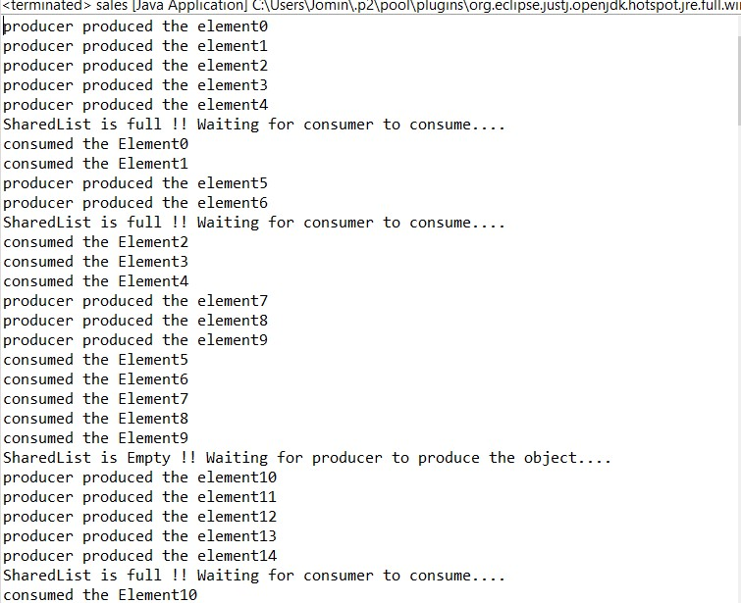

**Program 15**

24/06/2021

**Aim:** Program to create a generic stack and do the Push and

Pop operations.

**Algorithm:**

Step 1: Start

Step 2: Define a stack .

Step 3: Push();

If top<n

Top++

Stack[top]=n.

Step 4: Pop()

If top!=1

.top--

Step 5: Print the stack.

Step 6: Stop

**Source Code:**

package Graphics;

import java.util.*;

public class Stack {

int top=-1,ch,item,i;

int a[] = new int[10];

Scanner sc = new Scanner(System.*in*);

public static void main(String[] args) {

Stack st = new Stack ();

st.stack();

}

public void stack(){

System.*out*.println("Enter the size of the stack:");

int N=sc.nextInt();

do

{

System.*out*.println("\nEnter your choice ");

System.*out*.println("\n 1.Push \n 2.Pop \n 3.Display \n");

ch=sc.nextInt();

switch(ch){

case 1:

System.*out*.println("Enter the element to be inserted:");

item=sc.nextInt();

if(top==N-1) {

System.*out*.println("Stack overflow!");

}

else {

top++;

a[top]=item;

}

break;

case 2:

if(top==-1) {

System.*out*.println("Stack is empty!!");

}

else {

item=a[top];

top--;

System.*out*.println("Deleted element is:" +item);

}

break;

case 3:

if(top==-1)

{

System.*out*.println("Stack is empty!!");

}

else

{

System.*out*.println("Displaying elements in the Stack:\n");

for(int i=top;i>=0;i--)

{

System.*out*.println(a[i]);

}

}

break;

case 4: System.*out*.println("Enter a valid choice");

}

}

while(ch!=5);

}

}

**Output:**

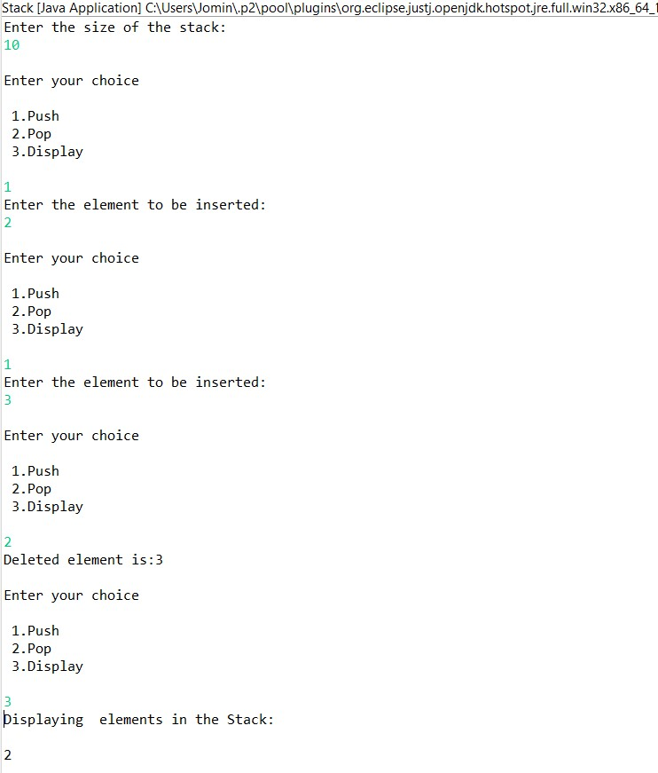

**Program 16**

24/06/2021

**Aim:** Using generic method perform Bubble sort.

**Algorithm:**

Step 1: Start

Step 2: Look at the first number in the list.

Step 3: Compare the current number with the next number.

Step 4: Is the next number smaller than the current number? If so, swap the two numbers around. If not, do not swap.

Step 5: Move to the next number along in the list and make this the current number.

Step 6: Repeat from step 2 until the last number in the list has been reached.

Step 7: If any numbers were swapped, repeat again from step 1.

Step 8: If the end of the list is reached without any swaps being made, then the list is ordered and the algorithm can stop.

Step 9: Stop

**Source Code:**

package packoops;

import java.util.*;

public class bubblesort {

public static void main(String[] args) {

int num, i, j, temp;

Scanner x = new Scanner(System.*in*);

System.*out*.println("Enter the limit to be sort:");

num = x.nextInt();

int array[] = new int[num];

System.*out*.println("Enter " + num + " integers: ");

for (i = 0; i < num; i++)

array[i] = x.nextInt();

for (i = 0; i < ( num - 1 ); i++) {

for (j = 0; j < num - i - 1; j++) {

if (array[j] > array[j+1])

{

temp = array[j];

array[j] = array[j+1];

array[j+1] = temp;

}

}

}

System.*out*.println("Sorted list of integers:");

for (i = 0; i < num; i++)

System.*out*.println(array[i]);

}

}

**Output:**

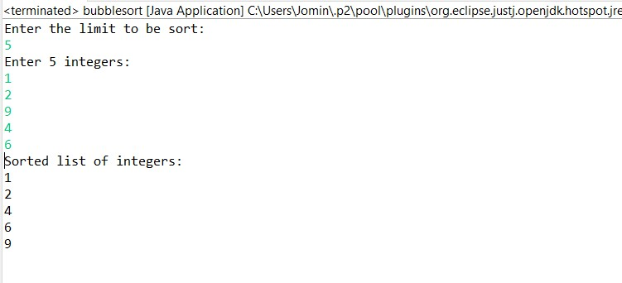

**Program 17**

24/06/2021

**Aim:** Maintain a list of Strings using Array List from

collection framework, perform built-in operations.

**Algorithm:**

Step 1: Start

Step 2: Define an array.

Step 3: Define objects to array.

Step 4: Perform operation on array.

Step 5: Print the array after operations.

Step 6: Stop

**Source Code:**

package packoops;

import java.util.*;

public class Arraylist

{

public static void main(String[] args)

{

ArrayList<String> obj=new ArrayList<String>();

obj.add("one");

obj.add("Three");

obj.add("four");

obj.add("five");

obj.add(1,"two");

System.*out*.println("\n Array list after operation:");

for(String str:obj)

System.*out*.println(str);

obj.remove("five");

obj.remove(3);

System.*out*.println("\n Array list after remove operation");

for(String str:obj)

System.*out*.println(str);

Collections.*sort*(obj);

System.*out*.println(" \n Array list after sorting");

for(String str : obj)

System.*out*.println(str);

System.*out*.println("\n Object at index 2:"+obj.get(2));

System.*out*.println("\n Six is in the arraylist:"+obj.contains("six"));

System.*out*.println("\n Two is in the arraylist:"+obj.contains("one"));

System.*out*.println("\n Size of the arraylist :"+obj.size());

obj.clear();

System.*out*.println("\n Arraylist after clear method:"+obj);

}

}

**Output:**

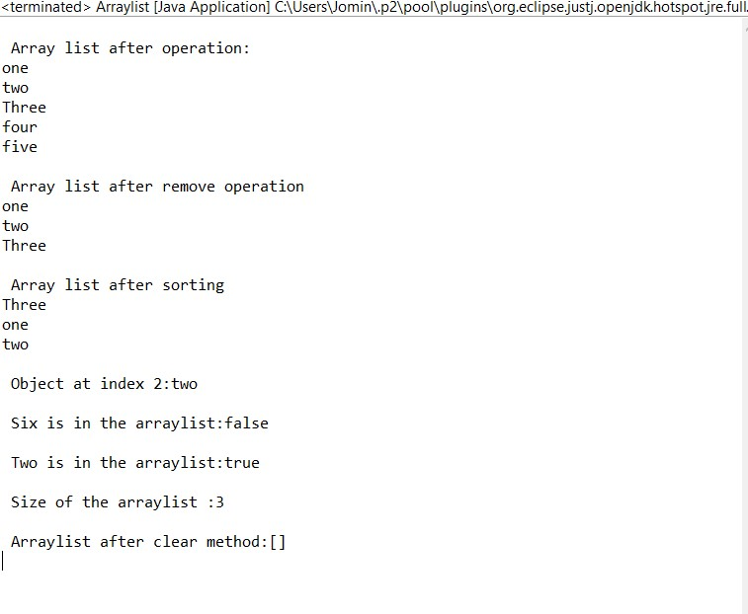

**Program 18**

24/06/2021

**Aim:** Program to remove all the elements from a linked list.

**Algorithm:**

Step 1: Start

Step 2: Define a Linked list.

Step 3: Define objects to Linked list using add().

Step 4: Delete the elements in list using clear()

Step 5: Print the Outputs.

Step 6: Stop

**Source Code:**

package packoops;

import java.util.*;

public class linklstremove {

public static void main(String[] args) {

LinkedList<String> list = new LinkedList<String>();

list.add("A");

list.add("B");

list.add("C");

list.add("E");

list.add("F");

list.add("G");

System.*out*.println("The Original linked list: " + list);

list.clear();

System.*out*.println("After removing : " + list);

}

}

**Output:**

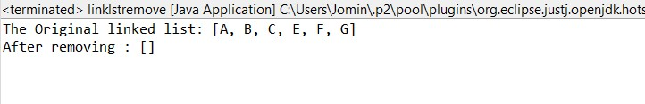

**Program 19**

24/06/2021

**Aim:** Program to remove an object from the Stack when the

position is passed as parameter.

**Algorithm:**

Step 1: Start

Step 2: Define a Stack.

Step 3: Define objects to Stack using add().

Step 4: Enter the element to remove the item.

Step 5: Remove the item using remove(key).

Step 6: Print outputs

Step 7: Stop

**Source Code:**

package packoops;

import java.util.*;

public class stack {

public static void main(String[] args) {

Scanner s = new Scanner(System.*in*);

int i,n;

System.*out*.println("Enter the list of numbers to be added:");

int a=s.nextInt();

Stack <Integer> st = new Stack <Integer>();

for(i=1;i<=a;i++) {

System.*out*.println("Enter the "+(i)+"st number:");

n=s.nextInt();

st.add(n);

}

System.*out*.println("Original Stack:"+st);

System.*out*.println("\nEnter the index to be removed:");

int index = s.nextInt();

int rm_ele = st.remove(index);

System.*out*.println("Removed Element is:"+rm_ele);

System.*out*.println("\nStack after updation:\n"+st);

}

}

**Output:**

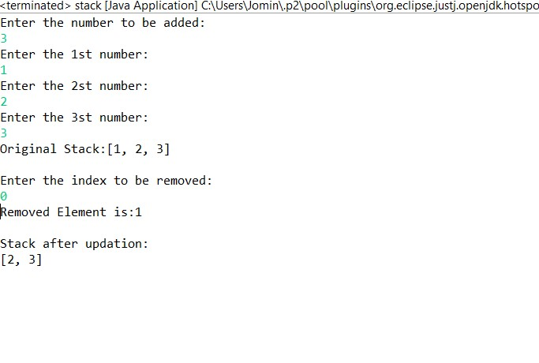

**Program 20**

24/06/2021

**Aim:** Program to demonstrate the creation of queue object

using the PriorityQueue class.

**Algorithm:**

Step 1: Start

Step 2: Define a Priority Queue.

Step 3: Enter the limit.

Step 4: Add n elements to Queue.

Step 5: Perform operations like remove(), add() etc.

Step 6: Print output.

Step 7: Stop

**Source Code:**

package packoops;

import java.util.Iterator;

import java.util.PriorityQueue;

import java.util.Scanner;

public class queuepri

{

public static void main(String args[])

{

PriorityQueue<String> queue=new PriorityQueue<String>();

Scanner sc=new Scanner(System.in);

System.out.println("Enter Number Of elements ");

int n=sc.nextInt();

System.out.println("Enter the elements ");

for(int i =0;i<n;i++)

{

String st=sc.next();

queue.add(st);

}

System.out.println("head:"+queue.element());

System.out.println("head:"+queue.peek());

System.out.println("Iterating the queue elements\n ");

Iterator itr=queue.iterator();

while(itr.hasNext()){

System.out.println(itr.next());

}

queue.remove();

queue.poll();

System.out.println("After removing two elements \n");

Iterator<String> itr2=queue.iterator();

while(itr2.hasNext()){

System.out.println(itr2.next());

}

}

}

**Output:**

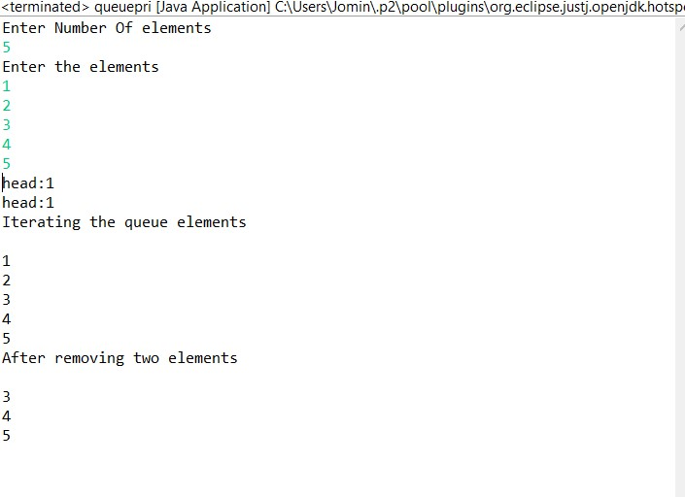

**Program 21**

24/06/2021

**Aim:** Program to demonstrate the addition and deletion of

elements in deque.

**Algorithm:**

Step 1: Start

Step 2: Define an Array.

Step 3: Define objects to Array using add(),

Step 4: Perform desired operations.

Step 5: Remove the item using pop().

Step 6: Print outputs

Step 7: Stop

**Source Code:**

package packoops;

import java.util.ArrayDeque;

import java.util.Deque;

public class deque {

public static void main(String[] args) {

Deque<Integer> deque = new ArrayDeque<Integer>();

deque.add(1);

deque.add(2);

deque.add(3);

System.out.println("Inserting three elements : ");

for (Integer integer : deque) {

System.out.println(integer);

}

deque.pop();

System.out.println("After popping : ");

for (Integer integer : deque) {

System.out.println(integer);

}

deque.remove(3);

System.out.println("Removing the element 3 :"+deque);

}

}

**Output:**

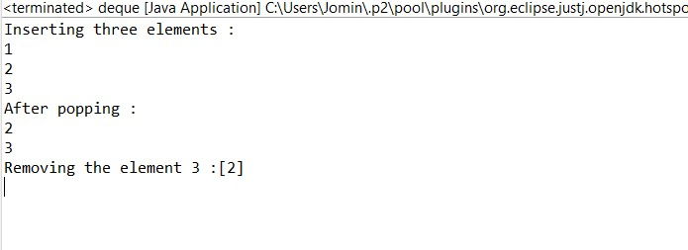

**Program 22**

24/06/2021

**Aim:** Program to demonstrate the creation of Set object using

the Linked Hashset class.

**Algorithm:**

Step 1: Start

Step 2: Define a Linkedhash set.

Step 3: Define objects to Linked hash set using add().

Step 4: Perform desired operations like printing the elements and size of the hash set.

Step 5: Remove the item using remove(key).

Step 6: Print outputs

Step 7: Stop

**Source Code:**

package packoops;

import java.util.LinkedHashSet;

import java.util.Scanner;

import java.util.Set;

import java.util.Iterator;

public class linkedhastset {

public static void main(String[] args) {

Set<Integer> s = new LinkedHashSet<Integer>();

System.out.println("Enter the limit to be added");

Scanner inp=new Scanner(System.in);

int n=inp.nextInt();

System.out.println("Enter the Number:");

while(n!=0) {

int e = inp.nextInt();

s.add(e);

n--;

}

System.out.println("Set is "+s);

System.out.println("Enter the number to be deleted:");

int d= inp.nextInt();

if(s.remove(d)) {

System.out.println("Removed!!"+s);

}

else {

System.out.println("Element is not in the set");

}

Iterator<Integer> l = s.iterator();

while(l.hasNext())

System.out.println(l.next());

}

}

**Output:**

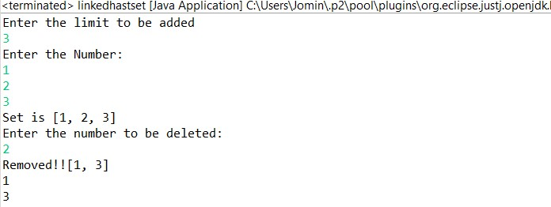

**Program 23**

24/06/2021

**Aim:** Write a Java program to compare two hash set.

**Algorithm:**

Step 1: Start

Step 2: Define 2 hash sets h_set and h_set2.

Step 3: Define objects to hash h_set and h_set2 using add().

Step 4: Compare the hash sets; if its same.

Step 5: Print Yes

Step 6: Else Print No

Step 7: Stop

**Source Code:**

package packoops;

import java.util.*;

public class hashcomp {

public static void main(String[] args) {

HashSet<String> h_set = new HashSet<String>();

h_set.add("Red");

h_set.add("Green");

h_set.add("Black");

h_set.add("White");

HashSet<String>h_set2 = new HashSet<String>();

h_set2.add("Red");

h_set2.add("Pink");

h_set2.add("Blue");

h_set2.add("Orange");

HashSet<String>result_set = new HashSet<String>();

for (String element : h_set){

System.*out*.println(h_set2.contains(element) ? "Yes" : "No");

}

}

}

**Output:**

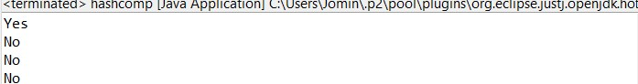

**Program 24**

24/06/2021

**Aim:** Program to demonstrate the working of Map interface

by adding, changing and removing elements.

**Algorithm:**

Step 1: Start

Step 2: Define a class mapcoll

Step 2: Define a Map set mp.

Step 3: Define objects to Map set mp using put().

Step 4: Remove the elements using remove().

Step 5: Print the Outputs.

Step 6: Stop

**Source Code:**

package packoops;

import java.util.*;

public class mapcoll {

public static void main(String args[])

{

Map<Integer, String> mp = new HashMap<>();

//Inserting elements..

System.*out*.println("Enter the limit:");

Scanner inp = new Scanner(System.*in*);

int n= inp.nextInt();

System.*out*.println("Enter the Roll number and Name");

while(n!=0) {

int e= inp.nextInt();

String s= inp.next();

mp.put(e, s);

n--;

}

System.*out*.println("Initial Map:"+mp);

System.*out*.println("enter the num and name to update:");

Scanner in = new Scanner(System.*in*);

int e= in.nextInt();

String s= in.next();

mp.put(e, s);

System.*out*.println("Updated Map:"+mp);

//Removing..

System.*out*.println("Enter the Roll number to be removed:");

int r=inp.nextInt();

mp.remove(r);

// Final Map..

System.*out*.println("After Removing the entry, Final Map is:"+mp);

}

}

**Output:**

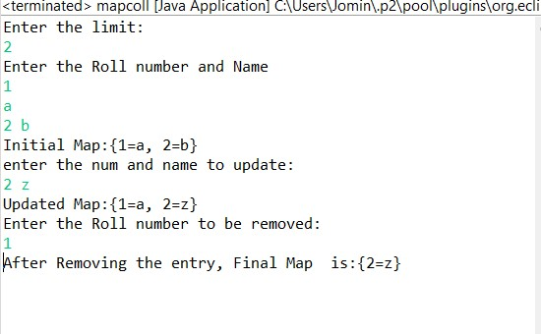

**Program 25**

24/06/2021

**Aim:** Program to Convert Hash Map to Tree Map.

**Algorithm:**

Step 1: Start

Step 2: Create a class hashtotree

Step 3: Define a map.

Step 4: Define objects for map using put().

Step 5: Define a tree set treeMap

Step 6: Convert map set into tree using treeMap.putAll().

Step 7: Print the Outputs.

Step 8: Stop

**Source Code:**

package packoops;

import java.util.*;

public class hashtotree {

public static void main(String args[]) {

Map<String, String> map = new HashMap<>();

System.*out*.println("Enter the limit:");

Scanner inp = new Scanner(System.*in*);

int n= inp.nextInt();

System.*out*.println("Enter the Roll number and Name");

while(n!=0) {

String e= inp.next();

String s= inp.next();

map.put(e, s);

n--;

}

System.*out*.println("HashMap:"+map);

Map<String, String> treeMap = new TreeMap<>();

treeMap.putAll(map);

System.*out*.println("TreeMap:"+treeMap);

}

}

**Output:**

